16. Develop a system using UML for Online Internship Registration System. It should verify the details of the candidate by the central computer. The details regarding the candidate will be provided to the central computer through the administrator and the computer will verify the details of the Page 3 of 6 candidate and provide approval. Then the internship letter will be issued from the company to the candidate.

**Class Diagram :**

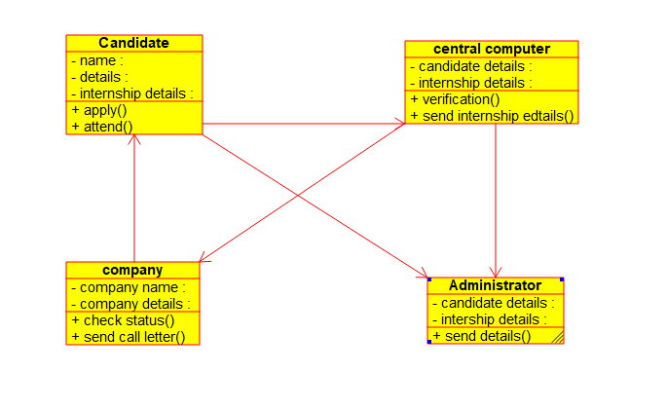

**Package Diagram :**

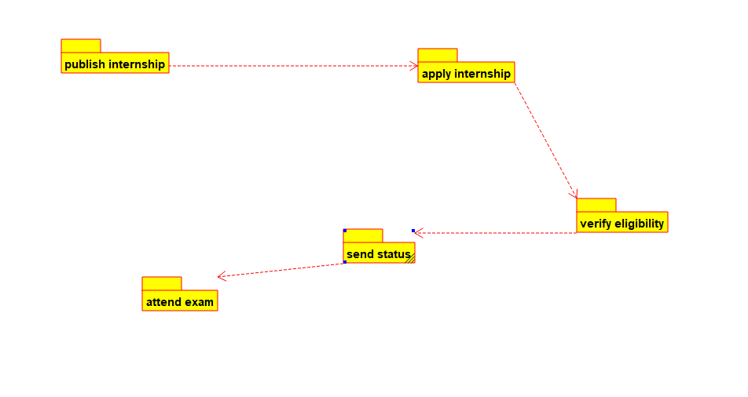

**State Diagram :**

